Assignment
- 1) Explain the Difference between Abstract Class and Interface with example programs
Abstract method
An abstract class is a class declared using the abstract keyword. It can contain:
- Abstract methods (without body)
- Concrete methods (with body)
- Variables
- Constructors
- Static methods

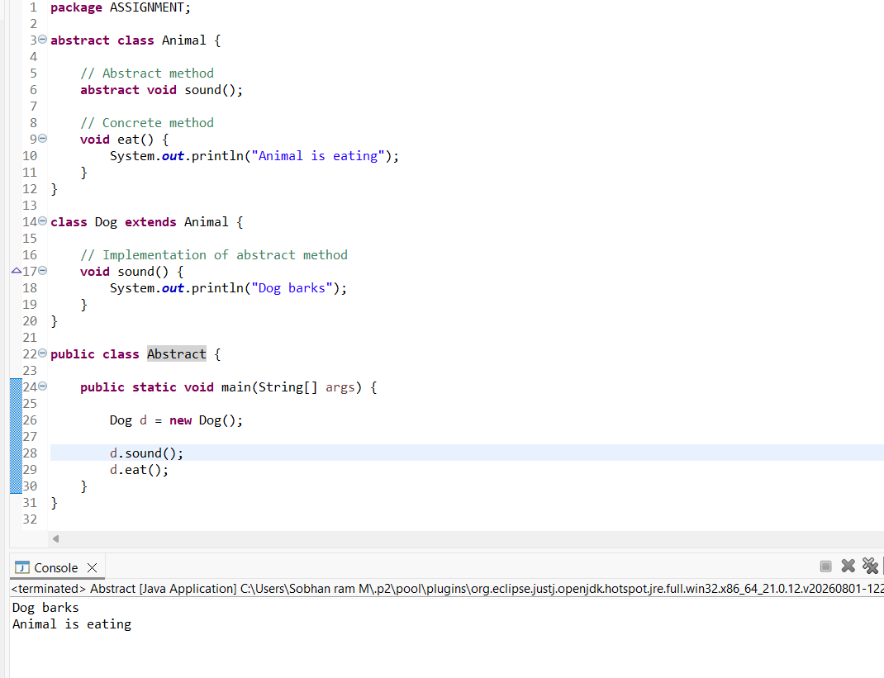
Here, Animal provides both an abstract method (sound()) and a normal method (eat()).

2) Interface
An interface is mainly used to define a contract that implementing classes must follow.
Methods in an interface are traditionally abstract by default. Modern Java interfaces can also contain default and static methods.
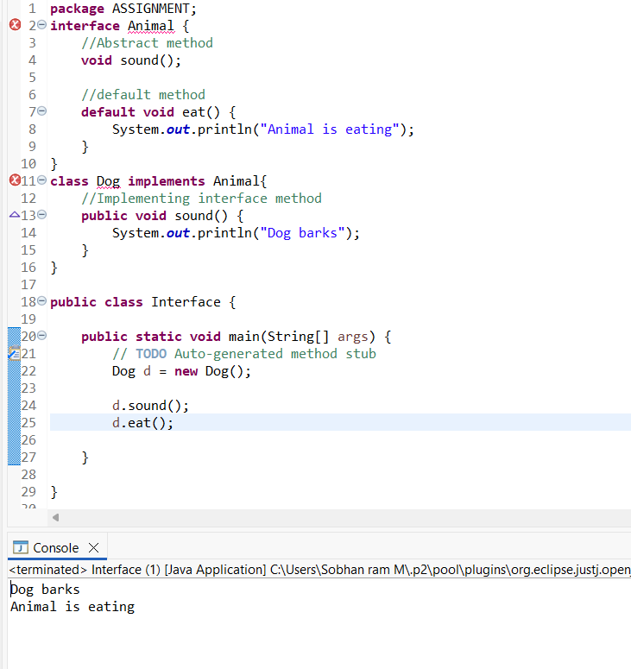

Abstract Class vs Interface
Feature | Abstract Class | Interface
Keyword | abstract class | interface
Inheritance | extends | implements
Methods | Abstract + concrete methods | Abstract + default/static methods
Variables | Can have instance variables | Variables are public static final by default
Constructor | Yes | No
Multiple inheritance | A class can extend only one class | A class can implement multiple interfaces

2) Explain about Overloading and Overriding with example programs
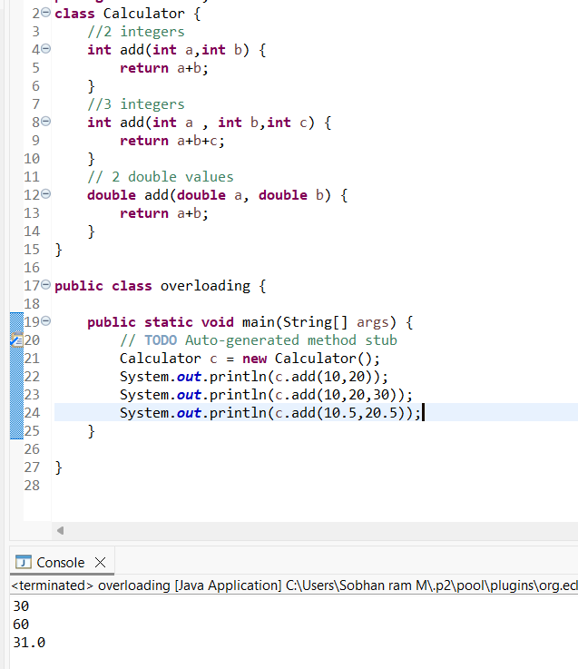
Overloading = Same method name, but different parameters.
Imagine you have a method called add().
You want to add:
- 2 numbers
- 3 numbers
- 2 decimal numbers
You can use the same method name add(), but change the parameters.
2) Overriding
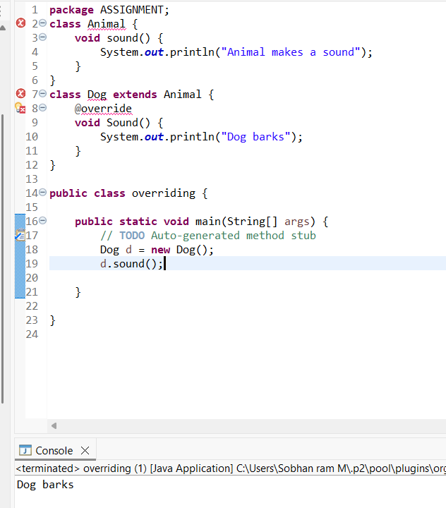
OVERRIDING = REPLACE
The child replaces/changes the behavior inherited from the parent.
Animal
↓
sound() → Animal sound

Dog
↓
sound() → Dog barks

